UML (Unified Modelling Language)
easy to remember (U SBI E)
- Structural View (Class diagram, Object diagram)
- Behavioral View (Sequence diagram,state-chart diagram, activity diagram, collaboration diagram)
- Implementation View (Component diagram)
- Environment View (Deployment diagram)
- User's View (Usecase diagram)

Usecase Diagram
Includes Generalization, Aggregation, Association, Include and Extend relations.
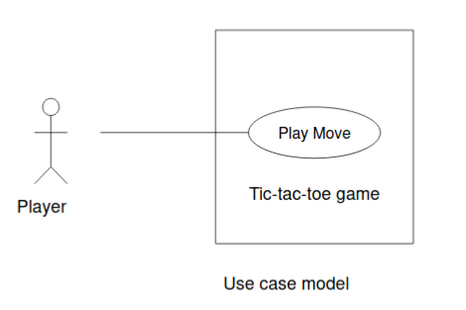

Class Diagram
Describes static structure of a system

State-Chart Diagram
Models how the state of an object changes in its life time.
Based on finite state machine (FSM) formalism

